Experiment 26
Aim
To write a Prolog program to find the color of fruits using backtracking.
Algorithm:
Start
- Define facts representing different fruits and their corresponding colors.
- Define a predicate fruit_color(Fruit, Color) to find the color of a given fruit.
- Give a query with the fruit name or leave the fruit variable unbound.
- Prolog searches the facts from top to bottom.
- If a matching fruit is found, display its color.
- Press ; to activate backtracking and find the next matching fruit.
- Continue until all possible answers are found.
- Display all fruit-color combinations.
- Stop.
Code:
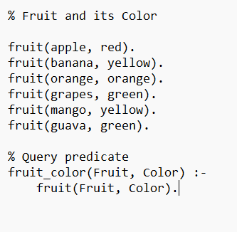
Output;
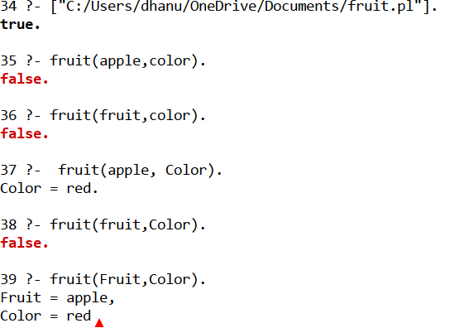
Result:
Thus the prolog program to to find the color of fruits using backtracking is executed successfully.

